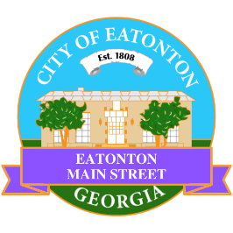

Eatonton Main Street
Advisory Board Meeting Agenda
October 11, 2022

Eatonton Main Street's Mission Statement:
To preserve and to enhance the historical and the cultural character of Eatonton through economic development.

Eatonton Main Street's Vision Statement:
Eatonton Main Street will be thriving and beautiful, rich in culture and heritage, sustained by community support.

- Call to Order

- Welcome
  - EQ Check-In
  - Approval of the Minutes from the September Meeting
  - Financial Report

- Old Business
  - New Board Officer
  - Update on Wayfinding Signage
  - Update on Downtown Mural

- New Business
  - Rise & Shine Agenda
  - Manager Update
    - Scarecrow Contest
    - Christmas Lights

- Façade Grants
  - None at this time

- Board News & Announcements
  - City Council Meeting at 7:00pm on Monday, October 17th at the Putnam County Administration Building
  - Rise & Shine Meeting in Prime Time at 6:30pm on Tuesday, October 26th at Eat-A-Ton Café
  - Mistletoe Market on Saturday, November 12th on the Courthouse Lawn
- Adjournment

Next Meeting: November 8, 2022 | 6:00pm | The Hut

