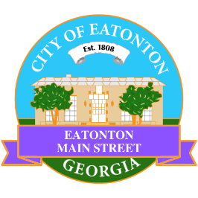

Eatonton Main Street
Advisory Board Meeting Agenda
August 12, 2025

Eatonton Main Street's Mission Statement:
To preserve and to enhance the historical and the cultural character of Eatonton through economic development.

Eatonton Main Street's Vision Statement:
Eatonton Main Street will be thriving and beautiful, rich in culture and heritage, sustained by community support.

- Call to Order

- Welcome
  - EQ Check-In
  - Approval of the Minutes from the July meeting
  - Financial Report

- Old Business
  - Review of the Workplan

- New Business
  - Walks About Nothing
  - Upcoming Events
    - Downtown Eatonton Farmer’s Market (August & September)
    - Downtown GetDown Concert (September)
    - An Evening in Eatonton (September & December)
    - Scarecrow Contest & Showcase (October)
    - Candy Mania (October)
    - Mistletoe Market (November)
    - Christmas in Eatonton Market & Parade (December)
  - Manager Report
    - Property Updates
      - 115-117 S. Jefferson Avenue sold for $350,000 (asking price was $450,000)
      - 115 S. Jefferson Avenue is available for lease for $1.25/square foot/month (about $3300)
      - 117 S. Jefferson Avenue will be turned into a “high end spa & nail salon”
      - 113 E. Marion Street (the former LumberJaxe) has been leased for a seafood bar & grill
      - 102 N. Madison Ave. (the former Blackwell Annex) is for sale for $250,000
- Façade Grants
  - None at this time

- Board News & Announcements
  - Downtown Eatonton Farmer’s Market on Friday, August 22nd from 5:00pm-8:00pm on N. Madison Avenue
  - Next Accountability Call is Tuesday, August 26th at 6:30pm
  - Next Downtown GetDown Concert will take place on September 13th with The Atlanta Jazz Players
    - 1-2 volunteers to help with band hospitality from 5:00pm-8:00pm

- Adjournment

Next Meeting: September 9, 2025 | 6:00pm | The Hut

