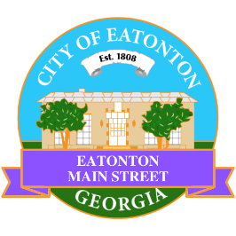

Eatonton Main Street
Advisory Board Meeting Agenda
March 4, 2025

Eatonton Main Street's Mission Statement:
To preserve and to enhance the historical and the cultural character of Eatonton through economic development.

Eatonton Main Street's Vision Statement:
Eatonton Main Street will be thriving and beautiful, rich in culture and heritage, sustained by community support.

- Call to Order

- Welcome
  - EQ Check-In
  - Approval of the Minutes from the February meeting
  - Financial Report

- Old Business
  - Review of the Workplan
  - Update on Business Visits
  - Board Vacancies

- New Business
  - Manager Report
    - Business Education Expo
    - Magnolia Market & Chalk Walk
    - Property Updates:
      - SIPS 31024 opened on March 1, 2025
      - 201 E. Sumter Street is for sale for $205,000
      - 108 N. Jefferson Avenue has been leased

- Façade Grants
  - Colonial State Holdings—108 N. Jefferson Avenue
  - Colonial State Holdings—110 N. Jefferson Avenue

- Board News & Announcements
  - Don’t forget your 2 hours of training!
  - Business Education Expo (BEE) on Tuesday, March 11th at 6:00pm at the Chamber of Commerce
  - Next Accountability Call is Tuesday, March 25th at 6:30pm
  - National Main Street Conference is April 6-9, 2025 in Philadelphia
  - Magnolia Market & Chalk Walk on Saturday, April 12th from 10:00am until 3:00pm
    - Volunteers will be needed from 7:45am until 9:45am to help load in vendors

- Adjournment

Next Meeting: April 15, 2025 | 6:00pm | The Hut

