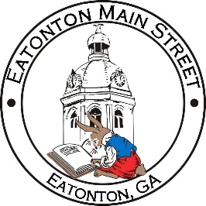

Eatonton Main Street
Advisory Board Meeting Agenda
August 10, 2021

Eatonton Main Street's Mission Statement:
To preserve and to enhance the historical and the cultural character of Eatonton through economic development.

Eatonton Main Street's Vision Statement:
Eatonton Main Street will be thriving and beautiful, rich in culture and heritage, sustained by community support.

- Call to Order

- Welcome
  - EQ Check-In
  - Approval of the Minutes from July Meeting
  - Financial Report
  - Team Exercise

- Old Business
  - Discussion of SWOT Analysis

- New Business
  - Discussion of Main Street Logo
  - September Board Meeting
  - Committee Updates
    - 2022 Vibrant Communities Grant

- Façade Grants
  - None at this time

- Board News & Announcements
  - Main Street 101 at www.GeorgiaMainStreet.org under “Training” (Deadline: Oct. 31st)
  - Makers & Music on Saturday, August 14th from 5:00pm-10:00pm
  - Business Education Expo (BEE) on September 14th, 21st, & 28th at the Chamber

- Adjournment

Next Meeting: September 2021 | 6:00pm | The Hut

